**NAME: JAMAN SAHAUL**

**ROLL NO: 10737**

**DEPARTMENT: MECHATRONICS**

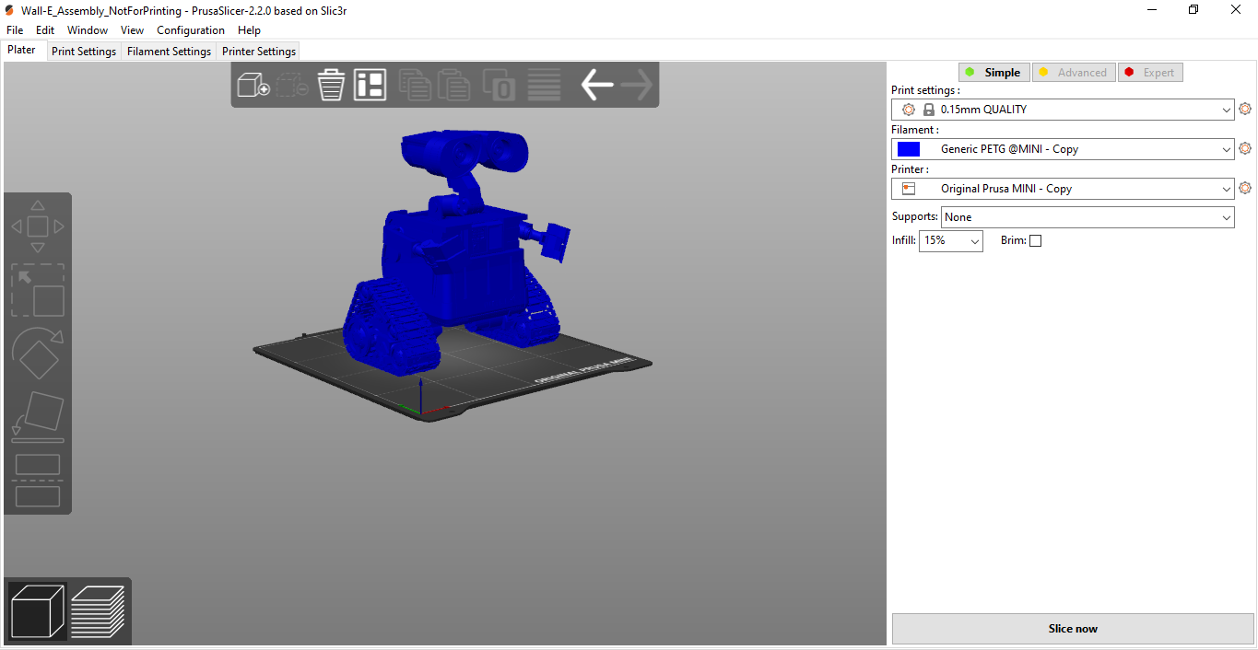

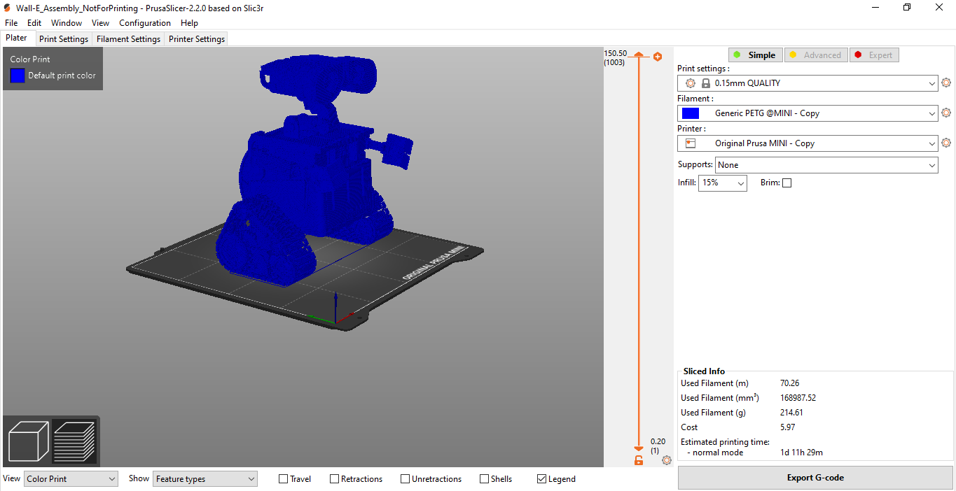

**G CODES:**

